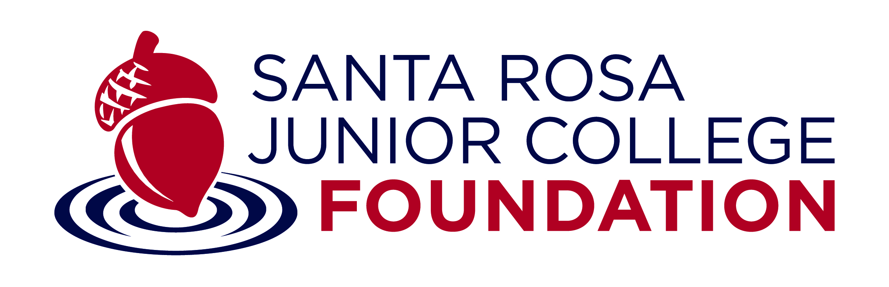

TITLE: Coordinator, Constituent Relations, SRJC Foundation

CLASSIFICATION: Classified

SALARY GRADE: O

POSITION DESCRIPTION AND SCOPE:
Under general direction, provides oversight for key constituent relationships such as the Board of Directors, donors, and affiliated trust committees; supports governance functions of the Board of Directors and affiliated trust committees; provides donor stewardship; conducts research to help build constituent relationships; and organizes key events to strengthen donor relations.

KEY DUTIES AND RESPONSIBILITIES:
Examples of key duties are interpreted as being descriptive and not restrictive in nature. Incumbents routinely perform approximately 80% of the duties below.

- Provides governance oversight for SRJC Foundation Board of Directors, and affiliated trusts including development of materials to comply with Brown Act requirements.
- Assists with facilitating the identification, recruitment, addition, and orientation of new volunteers.
- Identifies and communicates with scholarship donors to secure annual scholarship gifts.
- Develops, organizes, and facilitates donor stewardship events and donor interactions with scholarship recipients.
- Organizes and implements annual President’s Address to the Community.
- Creates and communicates quarterly updates to scholarship donors to provide updates on the process of identifying and reviewing scholarship recipients.
- Serves as lead liaison to the SRJC Scholarship Office to implement and facilitate donor use of fundraising and development systems to review student scholarship profiles and donor acknowledgments.
- Generates periodic reports for donors on the use of their donations to support programs.
- Researches and analyzes donor prospects to guide the Foundation in developing relationships with key constituents. Coordinates donor and prospect portfolios and provides monthly and quarterly reports on donor engagement.
- Provides administrative support to the Executive Director.
- Provides hospitality services to visitors to ensure an optimal customer experience.

KNOWLEDGE OF:
- Marketing, communications, and fund development strategies in an institution of higher learning and/or non-profit environment.
- Event development and coordination.
- Volunteer management.
- Standard office productivity software, including fundraising databases.
- Online research.

ABILITY TO:
- Interact with the public and provide outstanding customer service.
- Present information to groups of individuals.
- Create written content.
- Collaborate with a diverse set of stakeholders to achieve organizational goals.
- Plan and organize work and meet schedules and deadlines.
- Demonstrate sensitivity to, and respect for, a diverse population.
- Collaborate productively and cooperatively with individuals and groups both internally and/or externally.
- Communicate effectively, both orally and in writing.
- Exercise appropriate judgement in interactions with others and with work processes.
- Interact with the public in a helpful, courteous, and professional manner.

QUALIFICATIONS:
Candidates/incumbents must meet the minimum qualifications as detailed below, or file for equivalency. Equivalency decisions are made on the basis of a combination of education and experience that would likely provide the required knowledge and abilities. If requesting consideration on the basis of equivalency, an Equivalency Application is required at the time of interest in a position (equivalency decisions are made by Human Resources, in coordination with the department where the vacancy exists, if needed.)

EDUCATION:
Bachelor’s Degree.

EXPERIENCE:
3+ years of experience in marketing, communications, and/or fund development.

